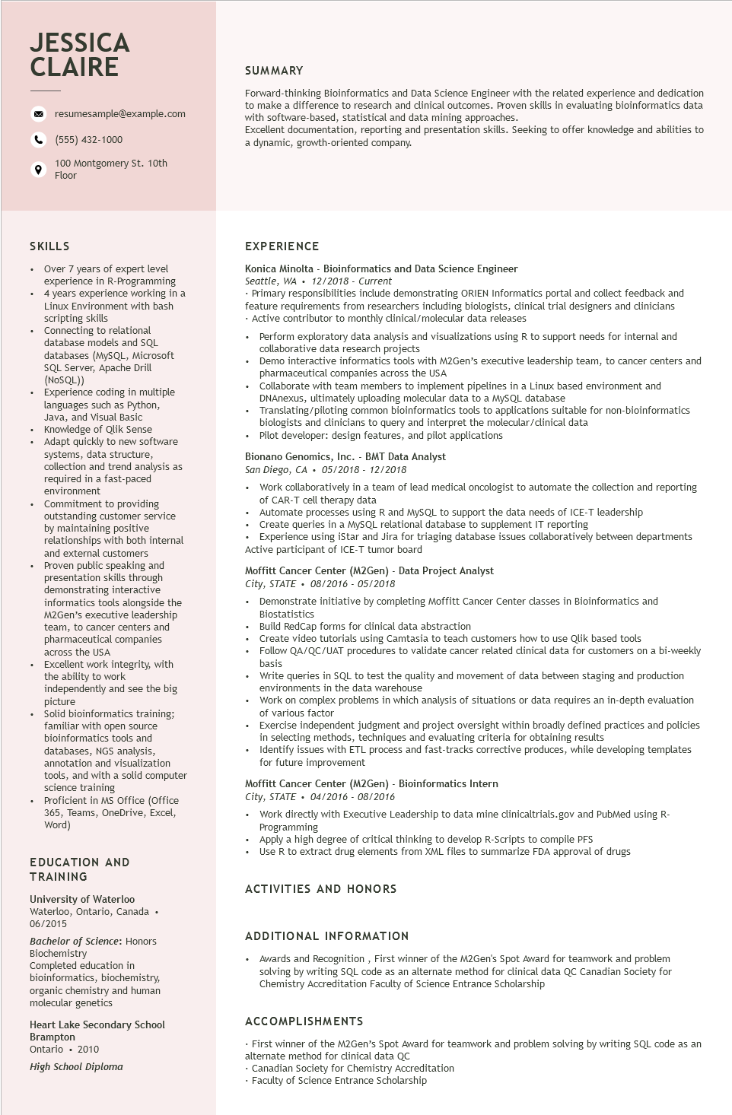
JESSICA CLAIRE
resumesample@example.com
(555) 432-1000
100 Montgomery St. 10th Floor
SUMMARY
Forward-thinking Bioinformatics and Data Science Engineer with the related experience and dedication to make a difference to research and clinical outcomes. Proven skills in evaluating bioinformatics data with software-based, statistical and data mining approaches.
Excellent documentation, reporting and presentation skills. Seeking to offer knowledge and abilities to a dynamic, growth-oriented company.
SKILLS
• Over 7 years of expert level experience in R-Programming
• 4 years experience working in a
·
•
.
+
Linux Environment with bash
scripting skills
Connecting to relational
database models and SQL
databases (MySQL, Microsoft
SQL Server, Apache Drill (NoSQL))
Experience coding in multiple
languages such as Python,
Java, and Visual Basic
Knowledge of Qlik Sense
Adapt quickly to new software
systems, data structure,
collection and trend analysis as
required in a fast-paced environment
Commitment to providing outstanding customer service by maintaining positive relationships with both internal and external customers Proven public speaking and presentation skills through demonstrating interactive informatics tools alongside the M2Gen's executive leadership team, to cancer centers and pharmaceutical companies across the USA
Excellent work integrity, with
the ability to work
independently and see the big picture
• Solid bioinformatics training; familiar with open source
•
bioinformatics tools and databases, NGS analysis, annotation and visualization
tools, and with a solid computer
science training
Proficient in MS Office (Office
365, Teams, OneDrive, Excel, Word)
EDUCATION AND TRAINING
University of Waterloo
Waterloo, Ontario, Canada. 06/2015
Bachelor of Science: Honors Biochemistry
Completed education in bioinformatics, biochemistry, organic chemistry and human molecular genetics
Heart Lake Secondary School Brampton
Ontario. 2010
High School Diploma
EXPERIENCE
Konica Minolta - Bioinformatics and Data Science Engineer Seattle, WA. 12/2018 - Current
• Primary responsibilities include demonstrating ORIEN Informatics portal and collect feedback and feature requirements from researchers including biologists, clinical trial designers and clinicians • Active contributor to monthly clinical/molecular data releases
• Perform exploratory data analysis and visualizations using R to support needs for internal and collaborative data research projects
• Demo interactive informatics tools with M2Gen's executive leadership team, to cancer centers and pharmaceutical companies across the USA
• Collaborate with team members to implement pipelines in a Linux based environment and DNAnexus, ultimately uploading molecular data to a MySQL database
Translating/piloting common bioinformatics tools to applications suitable for non-bioinformatics biologists and clinicians to query and interpret the molecular/clinical data
• Pilot developer: design features, and pilot applications
Bionano Genomics, Inc. - BMT Data Analyst
San Diego, CA⚫ 05/2018 - 12/2018
• Work collaboratively in a team of lead medical oncologist to automate the collection and reporting of CAR-T cell therapy data
• Automate processes using R and MySQL to support the data needs of ICE-T leadership
• Create queries in a MySQL relational database to supplement IT reporting
• Experience using iStar and Jira for triaging database issues collaboratively between departments Active participant of ICE-T tumor board
Moffitt Cancer Center (M2Gen) - Data Project Analyst
City, STATE⚫ 08/2016 - 05/2018
• Demonstrate initiative by completing Moffitt Cancer Center classes in Bioinformatics and Biostatistics
•
Build RedCap forms for clinical data abstraction
•
Create video tutorials using Camtasia to teach customers how to use Qlik based tools
• Follow QA/QC/UAT procedures to validate cancer related clinical data for customers on a bi-weekly basis
• Write queries in SQL to test the quality and movement of data between staging and production environments in the data warehouse
• Work on complex problems in which analysis of situations or data requires an in-depth evaluation of various factor
• Exercise independent judgment and project oversight within broadly defined practices and policies in selecting methods, techniques and evaluating criteria for obtaining results
• Identify issues with ETL process and fast-tracks corrective produces, while developing templates for future improvement
Moffitt Cancer Center (M2Gen) - Bioinformatics Intern
City, STATE⚫ 04/2016 - 08/2016
• Work directly with Executive Leadership to data mine clinicaltrials.gov and PubMed using R- Programming
Apply a high degree of critical thinking to develop R-Scripts to compile PFS
• Use R to extract drug elements from XML files to summarize FDA approval of drugs
ACTIVITIES AND HONORS
ADDITIONAL INFORMATION
• Awards and Recognition, First winner of the M2Gen's Spot Award for teamwork and problem solving by writing SQL code as an alternate method for clinical data QC Canadian Society for Chemistry Accreditation Faculty of Science Entrance Scholarship
ACCOMPLISHMENTS
First winner of the M2Gen's Spot Award for teamwork and problem solving by writing SQL code as an alternate method for clinical data QC
• Canadian Society for Chemistry Accreditation
• Faculty of Science Entrance Scholarship

